Technology in the Primary Curriculum
What is meant by ‘technological literacy’? Briefly discuss the relationship between science and technology and outline the place of technology in the primary curriculum. List and describe a range of ‘authentic’ technology projects suitable for given stages and topics by presenting three or four examples. (approx 700 words)

Technological Literacy
The development of proficiency in the use and application of technology is seen as a vital aspect of quality education in the primary curriculum due to its relevance in the modern world, seemingly infinite access to information and ability to support inquiry-based investigations as well as multiple intelligences through utilising children’s technological familiarity and ability (Martin, 2006, pp.429-431). According to the International Technology Education Association, technological literacy involves understanding “what technology is, how it is created, and how it shapes society, and in turn is shaped by society” (ITEA, 2007, p.9), which consequently facilitates a person’s capacity to make intelligent and informed decisions in a world driven by technology (Board of Studies NSW, 1993, p.2; 2012, p.11; Bybee, 2000; Ingerman & Collier-Reed, 2011, p.137).
The ability to “use, manage, assess and understand technology” (Ingerman & Collier-Reed, 2011, p.138; ITEA, 2007) allows teachers to engage, extend learning opportunities and develop technological literacy in their students through modelling appropriate interactions with equipment (Bybee, Powell, & Trowbridge, 2008, p.325). This indicates the importance of developing an understanding of interrelationships between technology, society and the environment through consideration of ethics, morals, socioeconomic impacts, appropriateness and bias when dealing with electronic equipment and digital media (Hodson, 2009, p.16; Martin, 2006, p.462). Furthermore, while computers and the internet are prominent elements in technological literacy, they comprise only a fraction of the vast human-built technology in our world (ITEA, 2007; Norton, Ritchie, & Ginns, 2007, p.204). This indicates the need for developing awareness, knowledge and appropriate interactions with the vast range of equipment which are individually chosen to suit particular contexts (Bybee et al., 2008, pp.268,269; Fleer & Jane, 2004, p.180; Ingerman & Collier-Reed, 2011, p.140).

The Relationship between Science and Technology in the Primary Curriculum
Within the primary curriculum science is seen as the knowledge, skills and understanding required to solve problems, whereas technology involves attempting to satisfy apparent human needs through managing and modifying both equipment and the natural environment (Board of Studies NSW, 1993, p.1; 2012, p.11; Hodson, 2009, p.13; ITEA, 2007; Sherman & Sherman, 2004, pp.5,10). Although the relationship between these two areas is very complex and dependent on contexts of particular learning experiences (Board of Studies NSW, 1993, p.2; Hodson, 2009, p.147), integrating science and technology in the primary curriculum is a beneficial practice for saving time, improving motivation, developing investigative understanding and facilitating multiple intelligences (Bybee et al., 2008, p.268; Fleer & Jane, 2004, p.53; Norton et al., 2007, p.205; Sherman & Sherman, 2004, p.3). However, it has been noted that successfully developing technological competency involves a holistic approach of incorporating technology across the primary curriculum, known as “technacy education” (Fleer & Jane, 2004, p.180), indicating its relevance in further frameworks. Furthermore, the use of technology is also gradually facilitating the shift towards using digital media rather than textbooks to present information, which has several advantages relating to financial savings, efficiency, accessibility and engagement (Bybee et al., 2008, p.270).
Technology’s place in the primary curriculum is highly directed by the cyclic and non-linear process of designing and making, which includes the aspects of investigation, ideation, production and evaluation (Board of Studies NSW, 1993, p.3; Norton et al., 2007, p.204) and effectively engages students in developing a product to solve a problem (Fleer & Jane, 2004, p.56; ITEA, 2007; Sherman & Sherman, 2004, pp.27, 354). The subtle differences between science and technology are highlighted in this process through science’s focus on explaining products contrasting with technology being based around the perceived efficiency and ingenuity of design (Hodson, 2009, p.13; Norton et al., 2007, p.203).

Authentic Technology Projects
Authentic technology activities using the design and make process should involve developing a product through an investigative process of defining a task, developing strategies to gather information, identifying and evaluating data, and applying and synthesizing information (Sherman & Sherman, 2004, p.11). While abundant physical equipment and tools exist that can be used to develop such projects, electronic tools such as internet research, webquests and multimedia can be effective for students to explore, interact with and present information (Bybee et al., 2008, p.267; Martin, 2006, p.450).

Examples of Authentic Technology Projects
Lower Grades (1,2)
- Work in groups to create boats through exploring materials, shape and design features which maximize flotation. This can occur through a sequence of discussion, experimentation and evaluation which effectively aligns with the design and make process while engaging students and developing their skills.
Middle Grades (3,4)
- Creating a model of the solar system in correct proportions using information about diameters of planets. This could occur through experimenting with physical materials such as paper-mache and clay or electronically using software such as Kid Pix to draw planets or present pictures (Sherman & Sherman, 2004, p.206)
Upper Grades (5,6)
- Using robotics to physically construct and program a machine to perform a given task effectively incorporates experimentation, information gathering and linking scientific concepts with technological equipment (Norton et al., 2007, p.210).
- Replicating the design of theme park rides (e.g. the Giant Drop at Dreamworld) allows for an exploration of materials, problem solving, linking science with mathematics and meaningfully investigating scientific concepts such as friction, force, acceleration, velocity, energy and momentum. (Norton et al., 2007, p.206)
Designing
This involves making decisions about the problem to be solved through clarifying the purpose of the product and the materials required in the project.

Appendix - The Cyclic Process of Designing and Making

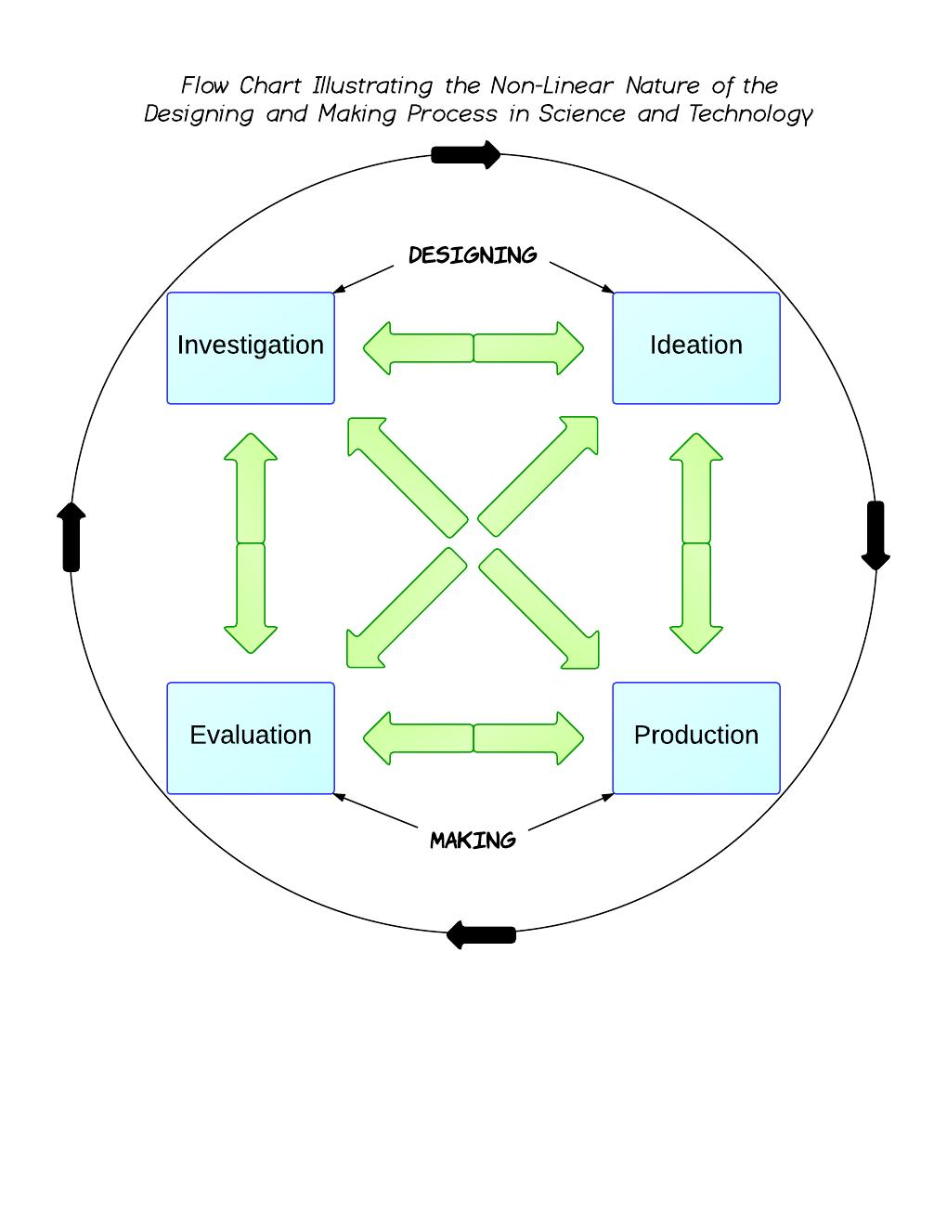
Making
This phase involves construction of products and appraisal. Following this the process may be repeated to improve the invention.

References
Board of Studies NSW. (1993). Science and Technology K-6 Syllabus and Support Document. Sydney: Board of Studies.
Board of Studies NSW. (2012). Science K–10 (incorporating Science and Technology K–6) Draft Syllabus. Sydney: Board of Studies.
Bybee, R. W. (2000). Achieving technological literacy: a national imperative. The Technology Teacher(September 2000), 23-28.
Bybee, R. W., Powell, J. C. , & Trowbridge, L. W. (2008). Teaching secondary school science: Strategies for developing scientific literacy. USA: Pearson Education Ltd.
Fleer, M., & Jane, B. (2004). Technology for Children: research-based approaches. Frenchs Forest: Pearson Education Australia.
Hodson, D. . (2009). Teaching and learning about science: Langauge, thoeries, methods, history, traditions and values. Rotterdam: Sense Publishers.
Ingerman, Ake, & Collier-Reed, Brandon. (2011). Technological Literacy Reconsidered: A Model for Enactment. International Journal of Technology and Design Education, 21(2), 137-148.
ITEA. (2007). Standards for technological literacy: content for the study of technology. from http://www.iteea.org/TAA/PDFs/xstnd.pdf
Martin, D. J. (2006). Elementary science methods: A constructivist approach. USA: Thomson Wadsworth.
Norton, S., Ritchie, S., & Ginns, I. (2007). Designing projects that integrate science and technology. In V. Dawson & G. Venville (Eds.), The art of teaching primary science (pp.202-215). Crows Nest: Vaille Dawson and Grady Venville.
Sherman, S. J., & Sherman, R. S. (2004). Science and science teaching: methods for integrating technology in elementary and middle schools. Boston: Houghton Mifflin Compant.

